4SS College Football Game Instructions

These instructions are meant to be used with Pete’s College Teams that have been created independently. They incorporate some house rules and modifications to better match the PC version 4.6. An MS Excel utility further expands some modifications. The instructions for this game have been divided into the following sections:

- game design explanations
- general play instructions
- advanced play instructions
- solo play instructions
- clarifications

1. Game Design

OVERVIEW

General knowledge of football is assumed.

Various all time great college football teams have been designed after extensive play testing with the PC Version 4.6. Each team is available in an MS Excel file and is represented on 8x11 (first through third string) “team sheets” and also a “platoon sheet”. Players from those teams are given ratings and coded play results to represent their contribution to the team’s results. Team and player stats are also provided in the MS Excel file.

Furthermore, various offensive plays for various offensive formations are represented on index sized play cards in MS Excel.

A table to decipher the play Result Codes, kick returns, and timing situations is required also.

Five dice are required as indicated: one 20 sided, one 12 sided, one 10 sided (numbered 0 to 9), and two six sided of preferably different color (I try to match one to each team’s colors).

The dice are referenced to the player cards, the offensive play cards and game tables.

A defensive player positioning and movement field is required for face to face games, but various defensive formation and player positioning sheets can be substituted for solo play. A table of down and distance situations can be utilized to select defensive player positioning during solo play.

Markers to indicate advanced options like keying, man to man coverage and double teaming should be created by the gamer if not playing solo.

Tokens numbered 1 to 11 represent the defensive players, but I use “Tudor Electric Football” figures instead.

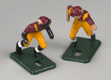

Player Ratings

Each player has been rated in several different areas. The main ratings however, are their “x A B C D E” numbers. These ratings are the “bread-and-butter” of the game.

While all players have been given “x A B C D E” ratings, the ratings themselves differ between offense and defense. For example, a DEFENSIVE lineman’s “A” rating reflects his ability at stopping the run. His “B” rating is his ability to rush the passer. Meanwhile, an OFFENSIVE lineman’s “A” rating judges his power blocking ability, and his “B” rating is a measure of how well he blocks on the move.

The table on the next page gives an explanation of what each position’s “x A B C D E” ratings are and an “average” value for each rating. Please note that the “average” ratings are really meant for starters. Backup players generally receive lower ratings.

Additionally, you’ll note that some players stand out as dominant playmakers and can truly dictate the flow and strategy of the game.

Player Ratings Table

 | x | A | B | C | D | E
Offensive Line  Avg Ratings | Supple-  5 | Power blocking  7 | Speed blocking  7 | Short pass blocking  7 | Med. pass blocking  7 | Long pass blocking  7
Quarterback  Avg Ratings | mental  3 | Inside runs  5 | Scramble  6 | Short passing  7 | Medium passing  7 | Long passing  7
Running Back  Avg Ratings | Blocking  5 | Inside runs  7 | Speed runs  7 | Short pass receiving  7 | Med. pass receiving  6 | Long pass receiving  5
Wide Receiver  Avg Ratings | Rating  3 | Inside runs  5 | Outside runs  6 | Short pass receiving  7 | Med. pass receiving  7 | Long pass receiving  7
Tight End  Avg Ratings | -  6 | Inside runs  6 | Outside runs  5 | Short pass receiving  7 | Med. pass receiving  7 | Long pass receiving  6
Defensive Line  Avg Ratings | -  3 | Run defense  3 | Pass rush  3 | Short pass defense  1 | Med. pass defense  0 | Long pass defense  0
Linebacker  Avg Ratings | -  3 | Run defense  3 | Blitz rush  3 | Short pass defense  3 | Med. pass defense  2 | Long pass defense  1
Defensive Back  Avg Ratings | -  3 | Run defense  2 | Blitz rush  2 | Short pass defense  3 | Zone pass defense  3 | Man pass defense  3
 | x | 30 | 40 | 50 | > | KO
Kicker  Avg Ratings | -  2 | FG<30 yds and PAT  NA | FG<40 yds  NA | FG<50 yds  NA | FG>50 yds  NA | Kickoffs  NA
 | x | <R | <N | >R | >N | KO
Punter  Avg Ratings | -  2 | Own side of 50-rush  NA | Own side of 50  NA | Opp side of 50-rush  NA | Opp side of 50  NA | Kickoffs  NA

These “average ratings” are for average starters.

Player Match ups

At the core of the game design is the concept of player match ups via an offensive formation’s play card. Each play card is designed to ultimately always compare ONE offensive player rating to ZERO, ONE, or TWO (known as “stacks”) defensive player(s) rating based upon which defensive field zone the play card dictates.

The play card will always call on ONE offensive player and only ONE defensive field zone based upon reference to a 20 sided die roll.

That’s not to say that these are the only players/zones that mattered on the play. They may have, in fact, had the smallest chance of being matched up for that particular play.

For example, you may run around the left end, yet have your right offensive tackle be the one who decides the play’s outcome, it just won’t happen as often as having your left offensive tackle decide the play’s outcome.

As offensive coach, it is your job to call plays in which the player match ups will favor your team’s ratings and result codes.

As defensive coach, it is your responsibility to adjust your defense by assigning each player a zone (there are 14 such zones) of the defensive field to occupy in order to prevent the offense from exploiting your weaknesses or matching up with unoccupied defensive field zones.

Player Cards

At first glance, you might believe that your defense would be best if you placed 11 defensive backs on the field at the same time because, except for their run defense, you would have better numbers on the field than with defensive linemen and/or linebackers. However, this is not true, because ALL players have a results column underneath each of the “A B C D E” (not x…this is explained later) ratings.

While a defensive back and a defensive lineman might both have the same “A” rating for instance, the results in the column for the lineman might average out to yield only 1 yard (or less), while the d-back’s might be over 3 yards! This is a significant difference, which you will grow to appreciate when setting up your defense.

Some examples of player card rating blocks found on the team sheets are listed below:

Kenny Stabler Gene Washigton Alan Page
QB Bama66 inj-1 WR MichSt66 inj+5 DE UND66 inj+5
x A B C D E x A B C D E x A B C D E
1 9 7 13 13 9 7 5 6 12 12 12 3 6 7 1 0 0
2~10 57 21 21 89 2~10 89 10 89 61 2~54 62 62 63 66
3~54 82 10 21 21 3~01 55 57 58 89 3~01 39 05 46 46
4~10 31 11 21 21 4~02 56 31 21 41 4~00 49 08 46 46
5~10 21 07 21 21 5~03 57 41 61 61 5~00 47 03 11 21
6~10 56 90 11 21 6~04 58 31 31 46 6~01 48 04 11 46
7~10 41 10 11 46 7~03 59 51 46 46 7~84 34 05 11 46
8~10 41 08 11 31 8~04 54 11 51 21 8~83 34 06 46 46
9~10 41 10 11 21 9~02 54 21 51 61 9~00 47 02 46 46
10~10 41 08 11 45 10~24 25 26 26 26 10~22 26 26 26 20
11~10 21 09 45 31 11~15 15 19 19 15 11~00 39 20 20 89
12~88 10 18 18 18 12~12 12 16 16 16 12~02 47 17 17 17
KR~6K(21) KC~3O KR~5K(21) KC~3O KR~5N(21) KC~3O
PR~5P(21)20 PC~3R PR~5P(21)20 PC~3S PR~7R(11)20 PC~3Q
Ret~S(31) Fat~0 Ret~S(51) Fat~5 Ret~S(89) Fat~5
Fm~11 Int~07 Ad~9 Fm~16 Int~20 Ad~1 Fm~20 Int~20 Ad~1

You also probably noticed that offensive ratings are generally higher than defensive ratings. This is because the two are subtracted and compared to a 10-sided die (d10) on virtually every play. Two six sided die (2d6) are added to get a result from 2-12 that is then cross referenced across the player card. The numbers under each A B C D E column are specialized result codes to be explained later.

For example, if A. Page and K.Stabler were matched up on a play with Stabler’s “B” rating and Page’s “A” rating in question, we would subtract Page’s (6) value from Stabler’s (7), resulting in a “1” (7 – 6 = 1). Therefore, if the 10-sided die rolled had a value of 1 or less (0 to 1), Stabler would win the match up and the result code for the play would be found on his card. If the die were higher than 1 (2 to 9), Page would win the match up and the play result code would be found on his card. Therefore, Page would have an 80% chance (8 of the 10 d10 rolls) of winning this match up. After studying the three players above (ratings and result codes) , you’ll find that they were special performers for their teams.

Punter Cards

Punter player cards have 4 punting columns. The “<R” or “>R” columns are used (“<R” if the ball is on the offense’s side of the 50, “>R” if on the 50 or on the defense’s side of the field) when a heavy rush has occurred as dictated (explained later) by a roll of the 20 sided die. If not, the “<N” or “>N” columns are used instead (“<N” for no rush and on the offense’s side of the field, “>N” for no rush and on the defense’s side of the field).

Placekicker Cards

Kickoff yardage is found under the “KO” column via result codes. On field goals and extra points, use the actual line of scrimmage and refer to the appropriate column on the kicker’s card. For example, on an extra point, the ball is at the 3 yard line. Therefore column “1+” would be used (1 to 10 yard line) on the kicker’s card. Kickers also have a long field goal rating located on their card. A kicker may not attempt a field goal from a distance (line of scrimmage) greater than this rating, unless an advanced rule for wind is being utilized.

Special Teams Player Cards

Each team has a platoon sheet, which not only includes lineups for different offensive and defensive formations, but also the special teams platoons.

The match up numbers on this sheet might not match the numbers on the special teams play cards because of formatting interests (some of the dice rolls may differ, but the dice roll percentages are the same).

Rather than using the “x A B C D E” ratings, special teams plays use the ratings at the bottom of the card…KR (kick return), KC (kick coverage), PR (punt return) and PC (punt coverage). Also, there are no columns on the player’s cards for special teams returns. Instead, players have all been given special teams letter grades, which are used with the Return Table.

For example, a player may have a kick return rating of “KR~8J(61)”. This means that the player has a KR rating of “8” (this is used similarly to the “x A B C D E” ratings on normal plays). If he were the player returning the kick, you would use the “J” column on the Returns section of the Return Table. If this player returns the kick, his long return is “61” (60 + d10 yards, as found on the Result Codes Table).

If the player is not returning the kick (but is still identified in the match up-he is instead blocking and only his numerical KR/PR rating is needed) and he wins the match up, use the returner’s return letter and return long rating for normal kicks. On squib and on-side kicks, he could be the returner and if so, use his own rating(s).

Punt return ratings have one additional value…specifically for fair catches. A player might have a string of values for his PR rating of “PR~7M(21)18”. Again, the player’s PR rating is 7 (similar to the “x A B C D E” numbers on normal plays). The “M” is the column identifier on the Return Table. The “21” is the player’s long return (20 + d10 yards). And the “18” is the player’s fair catch rating (on high punts, a d20 roll from 1-18 results in a fair catch, while rolls 19-20 are returned).

The frequency of long returns for kickoffs, punts, interceptions, fumbles etc are handled by the player’s “frequency rating, Fq” on his card. These are usually a 2 as the Returns Table has an “L” for long gain on the result of 2. However, some players have better frequencies of long returns. If a number other than 2 is listed, then the RC for that number is moved to the number 2 and the “L” is moved to the new long frequency number. Here is an example for a long frequency of 5 instead of 2:

2d6 die roll | Table results for “D” grade; Fq = 2 | Table results for “D” grade; Fq = 5
2 | L | 31
3 | 41 | 41
4 | 41 | 41
5 | 31 | L
6 | 21 | 21
7 | 21 | 21
8 | 21 | 21
9 | 21 | 21
10 | 31 | 31
11 | 41 | 41
12 | 41 | 41

If the coverage team wins the matchup, use his letter grade and a max long gain of RC 21 on KR and 90 on PR with no swap for long frequency.
Offensive Play Calling

After studying your team’s (player’s) strengths and weaknesses, it’s time to focus on the gameplan and playbook. A potential of six different offensive formations with some 200 plays are available. These have been modified for the college version. Some formations have been eliminated. A simple gameplan would cull this to a handful of formations/plays. Along the lines of BowlBound, you could just use a Pro Set formation and a few plays like FB Dive, FB Counter, HB End Run, HB Draw, Option, etc instead of the some 40 plays available out of that formation. The platoon sheets indicate the preferred formation for each team.

The Play Cards

The play cards are grouped under different formations. They provide information about each play, about which offensive players are matched up against which defensive field zone, which ratings each player(s) might be tested on, and how frequently each match up will occur.

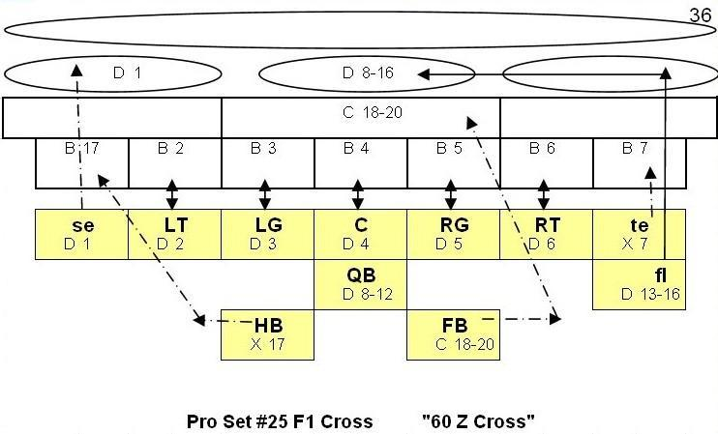

The preceding play diagram, named “Pro Set F1 Cross” (meaning “Flanker Cross from the Pro Set formation”), is an example. The larger letters, such as “se”, “LT”, “LG”, etc. represent individual offensive players (“se” for split end, “LT” for left tackle, etc.). A capital “FB” refers to fullback, while a lower case “fl” refers to flanker. In some formations, more than one flanker may be on the field at the same time, so a number may follow the letter. “f1” means flanker #1, “f2” means flanker #2, and so on.

Below is a table with the offensive player symbols and their meanings:

Symbol | Player
s,se | Split end
s1,se1 | First split end
s2,se2 | Second split end
T | Tackle
G | Guard
C | Center
t,te | Tight end
t1,te1 | First tight end
t2,te2 | Second tight end
f,fl | Flanker
f1,fl1 | First flanker
f2,fl2 | Second flanker
Q,QB | Quarterback
H,HB | Halfback
F,FB | fullback

The play cards also depict the defensive field zones. There are 14 such zones represented by shapes. One long pass oval, three medium pass ovals, three short (flat) pass rectangles, and seven blitz squares.

Each offensive player has been given “route lines”…lines which illustrate to which zone of the defensive field they are moving.

In the example play, the flanker is moving to the middle medium pass zone oval, the split end to the left (RCB) medium pass zone oval, the fullback is moving to the middle short pass zone rectangle, the tight end is blocking any player who might be in the far right pass rushing (blitz) zone square, the halfback is blocking any player who might be in the far left pass rushing (blitz) zone square, etc.

On the Pro Set #25 play card, you’ll see that below each offensive player is a letter, followed by a range of numbers. On our card, the flanker has a “D 13-16” beneath his “fl” symbol. Each play is executed by rolling all 5 (d20, d12, d10, 2d6) dice. On a 20-sided die (d20) roll from 13 through 16, the flanker’s “D” rating (medium pass rating) will be in question.

Defensive players are not represented on the play card because the defensive coach can set them in any zone and move them from zone to zone with special assignments. Although the play cards assign rigid zone destinations to the offensive players, the defensive players are free flowing and as such cannot be depicted on the play cards. Therefore, the zone in which a defensive player (or players) may reside is called into question instead.

Each play card will therefore have a d20 number (or range) for the offensive player and a corresponding number (or range) for the defensive zone. If that zone has a defensive player(s), then a comparison of their ratings will occur.

On the Pro Set Flanker Cross play, you’ll notice that the QB will have the greatest offensive influence on the play’s outcome (5 of 20 d20 chances) and the middle pass oval will have the greatest need of defensive player concentration (9 of 20 d20 chances).

On our example card, d20 rolls of 8 through 16 (shared between the QB’s and flanker’s D rating) are targeted toward the middle medium pass zone, and a defender(s) in that zone will also have his “D” rating (not always the same rating type) tested (if in zone coverage, as there are optional rules that can change this).

Since rolls 13-16 have already been discussed on the offensive side (those are calling on the flanker), rolls 8-12 must be referring to a different offensive player. If you look, you will see that indeed, the quarterback’s “D” rating is in question on rolls 8 through 12.

Other ratings could be tested based upon pass coverage defensive coaching options or different offensive player emphasis. This would generally represent dump off passes (see the FB on rolls 18-20) or key critical blocks (see the HB and TE on rolls 7 or 17). Therefore, this play card did also call for offensive x, C, or D ratings with defensive B, C, or D ratings.

Occasionally, the defense will set or move its players, so that a zone is unoccupied. If an unoccupied zone is called upon by a d20 roll, the offensive player automatically wins the match up. Conversely, if a zone has enough defensive rating points (generally from 2 players) that causes the net match up rating points to be negative, then the defense automatically wins the match up.

The Game Board

A modified game board has been created that does not subdivide the three linebacker (flat pass) zones, which was based on the design of the PC version 4.6. Therefore, defenders in the linebacker (flat pass) are not referenced as being directly behind any particular linemen (blitz) zone.

Time, field position, yardage for first downs, results, defensive and offensive player positions, and return results can all be kept track of on the original game board or by any suitable replacements.

The defensive side of the game board has four different levels and 14 distinct zones, as shown below:
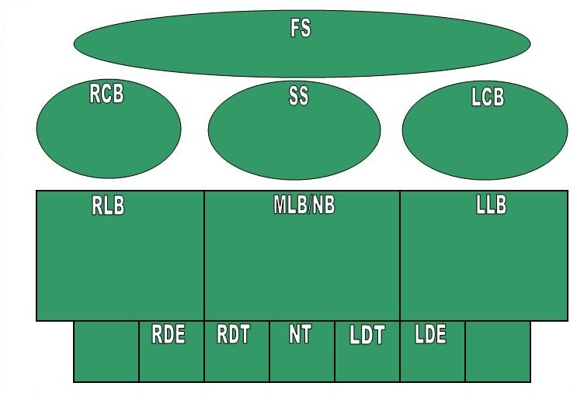
(1) Long (Deep) Pass Zone; limit of two defenders
(3) Medium Pass Zones; limit of two defenders
2
3
4
5
6
7
8
10
9
1
11
(3) Short (Flat) LB Pass Zones; limit of two defenders
(7) Run/Blitz (Linemen) Zones; limit of one defender
When filled with defensive player tokens, a 4-3 defense might look like this:
The limit of defensive players in any of the front seven lineman (blitz) zones is one. The limit of defensive players in any (flat, medium, long) pass zone is two.

At most, the defense can cover 11 of the 14 defensive field zones.

The Result Codes

Another key design concept of the game is the use of result codes instead of rigid play results. This allows for a tremendously wide variance of play results. However, the result codes, RC, are grouped and sequenced to allow gamers to quickly follow their meanings. Often, they serve to allow for expanded ranges of yards. For example, all results which end with a “1” are long gains. A RC of “11” for example, is 10 plus a d10 roll yards. A “21” is 20 plus a d10 roll yards, etc. Results “00” through “09” are 0 to 9 yard gains, respectively. Most of the results in the 50s are fumbles. Most of the results in the 60s are interceptions. Most of the results in the 80s are losses. A separate table of result codes should be printed out because of the inclusion of some new result codes. Below is a portion of the Result Codes Table:

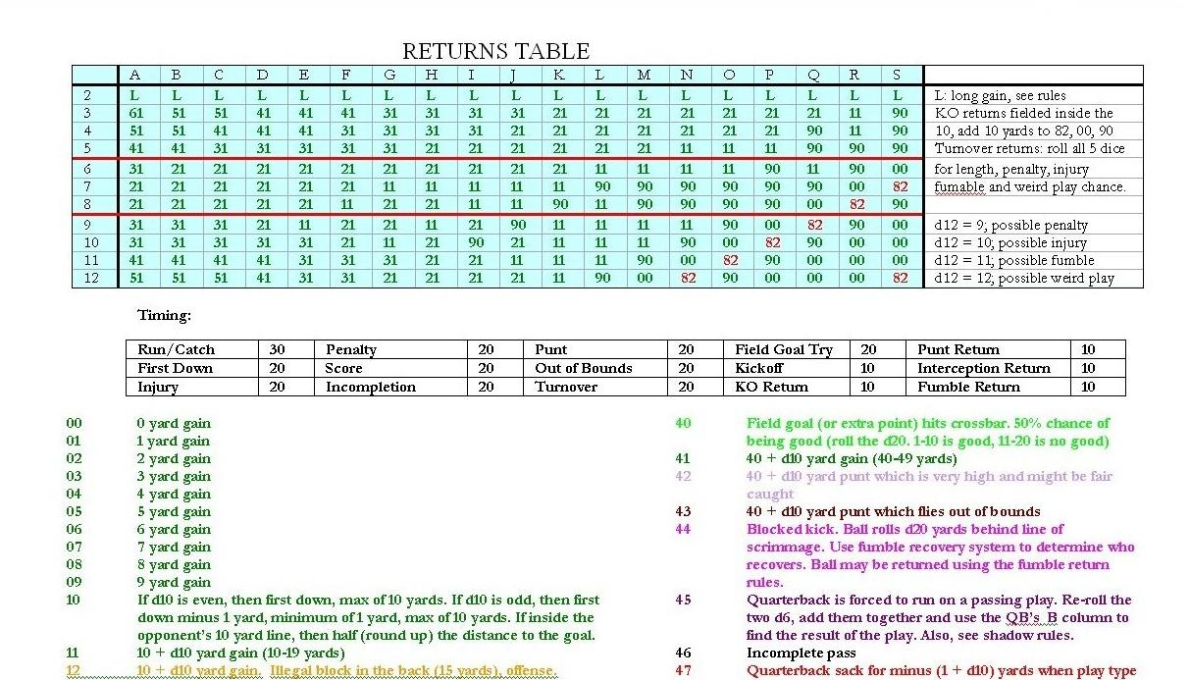

2. General Play Instructions

Setting up the Game

It is a good idea to organize everything in front of you before the game begins. You should include:

- five dice {one 20-sided (d20), one 10-sided (d10), one 12-sided (d12), and two 6-sided (2d6)}.
- markers to spot the ball, mark time, measure first downs etc.
- up to seven sets of offensive play cards (one set for each formation, plus one set for special teams plays)
- a defensive field with zones for player placement
- four sets of defensive play cards, if solo (one set for each formation) and a method to call defensive positioning
- team rating sheets (player cards)
- team platoon sheets (one for each team)
- player tokens or football figures (twenty-two of two different colors)
- Return Table and Result Codes Table

After looking at the player team sheets for the starting offense and defense, you may have noticed that the offensive team appears to be heading “north” (up) and the defensive team appears to be facing “south” (down). If you are playing solo, you may then abut one team’s offensive sheet with the other team’s defensive sheet to make them easier to match up, as the players facing off against each other will basically be adjacent to one-another.

If playing head to head, place a defensive token (numbered 1-11) on each defensive field zone on the game board you wish each defensive player to play. The tokens serve two purposes:

- identification of players
- indication of where the players are located or moved to subsequently

Alternatively, you may choose to cut out the players and place them on the field instead of using tokens. Also, the figures for “electric football” make good defensive player indicators.

If playing solitaire, the tokens are not needed, instead the d12 and the solo defensive formation cards should be referenced. A down and distance method of calling defensive plays (player positioning) is advisable.

The tokens are generally intended to match up with the following positions as generally found on the platoon sheets:

Token Number | Defensive Player | Offensive Player
1 | 4-3 LDE | QB
2 | 4-3 LDT | SE
3 | 4-3 RDT | FL
4 | 4-3 RDE | TE
5 | 4-3 LLB | FB
6 | 4-3 MLB | HB
7 | 4-3 RLB | LT
8 | 4-3 LCB | LG
9 | 4-3 RCB | C
10 | 4-3 SS | RG
11 | 4-3 FS | RT

When switching formations, use the positions listed on the platoon sheets to determine the token numbers. For example, in the Nickel defense, the 6th player down is the “NB” (nickel back), so his token number would be “6”.

Occasionally you will need to identify a player using the d12. Use the preceding table or platoon roster sheet as a guide. A d12 roll of 12 generally means that no player was identified, so the play finishes “as is”.

For example, on a fumble, the ball has rolled out of bounds at the spot. If identifying a player for an injury, a d12 roll of 12 means that no one was hurt.

Utilize any tools you have to mark the ball’s location, the distance for a first down, timeouts, and game time.

Starting the Game

Use the platoon sheets or the kickoff play cards as desired.

Typically, the board will look like this for a kickoff return:

6
1
7
3
7
4
7
5
7
7
7
8
7
9
7
10
7
11
7
2
7

Squib Kickoffs

Squib kicks are a second kick option. Squib kicks don’t travel as far as normal kicks, but are targeted toward players not accustomed to returning kicks. Read the distance on the squib kick play cards 3+, 4+ etc to be result code “31”, “41” etc.

Onside Kickoff

If the receiving team suspects an onside kick, they might counter it by moving more players up near the front:

1
7
2
7
3
7
4
7
5
7
6
7
7
7
8
7
9
7
10
7
11
7

In this setup, returns are unlikely. Furthermore, the returning team recovers all kicks unless 2d6 of 3 to 5 is rolled or if no receiving team player is in the attacked (kicked to) zone.

Returns

All players have been given KR and PR ratings, but most are NOT good return men. The best return men can be identified by their return letter grades. Typically, if the KR rating is higher than (before) a “K”, and if the PR rating is higher than (before) a “P”, the player is a decent return man. The closer to “A” the rating is, the better the chance for a good return.

Most players on the return team are actually blocking and not returning when their return rating is called upon.

If the player on the kicking (coverage) team wins the match up, use his KC or PC letter grade for the other team’s return. The return long is changed to RC “21” (on kickoff returns) and “90” (on punt returns).

Kicks successfully fielded in any of the “back” zones…including those occupied by players 6, 8, 10 and 11 in the illustration preceding…may be returned, even on an onside kickoff.

If the kicking team kicks deep (normal or squib) and no player is there to return the kick, the ball rolls through the end zone for a touchback.

Special Teams Play: KICK OFFS (KO)

Use the platoon sheet for quicker ratings and match up determinations.

D20 reveals match ups or distance zone on squib or on-side KO.
D12 reveals player making recovery.
D10 reveals yardage adjustments, when needed.
D6 (sum) reveals result codes (RC) or on-side KO recovery .

- Kicking team uses Kick Off platoon (Kick Off Coverage, KC).

- Receiving team uses Kick Return platoon (Kick Off Return, KR)

- Kicking team chooses Kick Off type, (normal, squib, on-side).

- Receiving team positions defenders for Kick Off type anticipated.

- Kicking team (KC) rolls both d6 and d10 for normal kicks and finds yardage RC from Placekicker’s “KO” column.

- Kicking team (KC) rolls all 5 dice for squib or on-side kicks and finds yardage RC from formation/play card. Note: 1+ is RC “11”, 2+ is “21”, 3+ is “31” etc.

- On-side kicks are recovered on 2d6 rolls of 3-5 or if d20 yields an empty zone.

- Normal or squib kickoffs that travel to an unoccupied zone are touchbacks.

- Kick Off yardage is measured from the 40 yard line.
Special Teams Play: KICK OFF RETURNS

D20 reveals players matching up.
D12 reveals penalties, injuries, fumbles, or weird plays.
D10 reveals match up winner or yardage adjustments if needed.
D6 (sum) reveals result codes (RC).

- Kick Off Return (KR) team decides if it will return kick off or call touchback.

- Kick Off Return (KR) team re-rolls all 5 dice for an elected return.

- Determine match up from platoon sheets or formation/play card from d20.

- Determine match up winner by comparison to d10 as for scrimmage plays.

- Determine RC from the Returns Table by summing the two d6 as for scrimmage plays. Add 10 yds to returns returned inside the 10 yard line on RC of “90”, “00”, or ”82”.

If the d12 = 1 to 8: And the return team (KR) won the match up, consult the kick off returnee’s (not match up blocker) KR letter rating (including his long gain) on the Return Table. If the KC team won the match up, use the KC rating for the match up player and use a RC of “21” for the long gain. For some squib and on-side match ups, the KR may be different than the primary or secondary returner.

In addition to the d12 = 1 to 8 above:

If the d12 = 9, then a possible penalty might have been called during the kick off return. Re-roll the d10 and use the table below for the penalty type.

0-2 | I Illegal block, returning team (15 yds)
3 | Holding, returning team (15 yds)
4-5 | Face Mask, coverage team (15 yds)
6 | Personal Foul, coverage team (15 yds)
7-9 | No Penalty occurred

To spot foul, re-roll all 5 dice, use RC “11”, but if d6 match, add d20, d12 and d10.

If the d12 = 10, then the player who lost the match up might have been injured.

If the d12 = 11, then a fumble is possible. Consult the fumble procedures.

If the d12 = 12, add the 2d6 and consult the Weird Play table. If a “no change” in the play results, re-roll all the dice. However, ignore another d12= 12.

The Clock

Under normal circumstances, the clock moves 3 ticks (30 seconds) on a run or completed pass, 2 ticks (20 seconds) on an incomplete pass, touchdown, safety, penalty, injury, turnover, kick from scrimmage, play out of bounds, or for first down when using post 1967 rules, and 1 tick (10 seconds) on any type of return. Use the lowest allotted time when discrepancies occur. For the last 30 seconds of each quarter, use 5 seconds (1/2 tick increments) of elapsed time per play.

The “slow down” offense may also be used. All plays have 10 seconds added to them (move the clock 1 additional space to those described above) except for successive incomplete passes, on which the second pass (and additional successive incomplete passes) take only 10 seconds.

The “hurry up” offense reduces all of the normal timings by 10 seconds.

In addition to the altered clockwork, the hurry up offense disallows any substitution (offensive or defensive) unless one of the teams calls a timeout or an injury occurs.

Each team is allotted four timeouts per half. Timeouts decrease the amount of time of all plays to 10 seconds.

Plays end up out of bounds when the indicated d20 from the play card references an outermost defensive zone (L/R frontline blitz, L/R flat, L/R medium) or deep pass zone. Sacks (RC 47, 48, 49) are excluded.

On the previously discussed Pro Set Flanker Cross, out of bounds plays would occur on d20 rolls of 1, 7, 17.

Playing the Game (Standard)

D20 reveals players matching up and their involved rating types.
D12 reveals solitaire defensive schemes if necessary.
D10 reveals whose card is used after winning the match up.
D6 (sum) reveals the result code (RC) from the winning player’s card.

- Check for Injury/Fatigue Status (optional). Offense makes substitutions first, then the defense.

- Offense reveals formation and selects play.

- Defense selects formation, coverage and movement.

- Offense reveals play and rolls all 5 dice

- The d20 reveals players matching up and their involved rating types.

- Subtract defensive from offensive rating points for the indicated match up. The d10 determines which player’s card to use. Defense, if match up points are negative or if d10 is greater than net match up rating points, offense otherwise. Offense, if no defender in match up.

- Add 2d6 together, and use RC found on the card of the player who won the match up under the correct column (A B C D E). If the offense won a match up calling for the “x” rating, sum the d6 for yardage on runs. Passes use the RC from the QB’s card column matching the intended receiver’s rating type. Otherwise, the play result is deciphered from the (RC) table.

- Fumbles require a check of the player’s fumble d20 rating to occur.

- Interceptions require a check of the QB’s interception d20 rating to occur.

- Stacks grant a bonus of one rating point to the defenders. The primary defender is identified by the lowest “token” number of the involved defenders.

- Defenders cover the entire short pass zone simultaneously except when determining run stacks.

- Pass rushes require occupation of the front linemen (blitz) zone.

- Man-to-Man, Combo, Double-teams, QB spies, and Keys may require subsequent movement of defenders.

- The RedZone (20 yard line in) allows the FS to vacate the deepest pass zone.

- The Crunch Zone (10 yard line in) allows certain rating point adjustments.

- Resolve a play to conclusion before enforcing/declining penalties.

Penalties

When a penalty result code (RC) occurs, re-roll the d12 and if a 9 is rolled, there is an offsetting penalty, canceling the play. Do not invoke when penalties are determined by the roll of the d12.

If a Result Code does not indicate the play result, roll a d20 and reference the play column on this table:

Fumbles

While some fumbles (especially those on special teams) occur because of certain die rolls, most are caused by a defensive player winning a match up and obliterating an offensive ball carrier!

When a fumble result code comes up, check the ball carrier’s fumble rating (“Fum”, found near the bottom of his rating block) first. Re-roll the d20 and compare it to the ball carrier’s fumble rating. If the roll is less than or equal to the rating, a fumble occurs. If not, no fumble occurs.

After a fumble occurs, roll the d12 and 2d6 dice. The 2d6 (read and deciphered separately as 11 to 66) determine which team recovered the fumble (11-35 offense, 36-66 defense). The d12 identifies the player who recovered the ball (the player with the token number equal to the d12 recovers). On a d12 roll of 12, the ball rolls out of bounds and is retained by the team fumbling, negating the 2d6 roll of 36-66. See the clarification section for fumbles on snaps or sacks.

To return a fumble, check the recovering player’s “Ret” rating (bottom of his rating block), roll all 5 dice, a d20 of 1 to 7 allows a return. Consult the two d6 and the Return Table for the yardage. If the d12 is an 11, the player who recovered the fumble, possibly fumbles the ball on the return, which starts the fumble process all over! To avoid this (and penalties), you may decline a return (“fall on the ball”) instead.

Fumbled Snaps

Any play utilizing a snap has a chance of a fumble 2 yards behind the line of scrimmage, if the d12 is an 11 and a re-roll of the 2d6 are also 11. Use the Center’s Fum rating.

Interceptions

Interception results are found on the defensive player’s cards. To determine whether or not an interception actually occurs, roll the d20 and consult the passer’s “Int” rating (near the bottom of his rating block). If the d20 is less than or equal to this number, the pass is indeed intercepted. However, if it is not an interception, then the pass is incomplete.

Additionally, if the result code would place the ball beyond the end zone, then the result is an incomplete pass. Note that 10 yards deep in the end zone is in bounds. Interceptions are returnable in the same manner as fumbles, except the d20 must be 1-13. Note: For statistical purposes, record the return as a 0 yard gain, if the d20 was 14-20.

Red Zone Defense

The “Red Zone” is defined in this game as the opponent’s 1 to 20-yard line. In this situation, all passes in which the deep long pass zone is called for in a match up are incomplete. For this reason, the free safety (token #11) may freely move up closer to the line of scrimmage without fear of being “burned”. This has a chain reaction, as other defensive backs are now available to move in to play run defense.

Crunch Zone Defense

The “Crunch Zone” is defined in this game as the opponent’s 1 to 10-yard line. Certain teams will have adjustments (CZF) as indicated on the team data sheet to their defensive player’s “A”, “B” and “C” rating points. Also, running play result codes of “10” automatically are changed to results of “half-the-distance to the goal” inside the opponent’s 10 yard line. Round up when needed (e.g., if the ball was at the 7 yard line and a play result of “10” occurs, the gain is for 4 yards).

Breakaway containment

Whenever a running play yields a result code of at least 20 yards (e.g. “21”, “27”, “31” etc.) first check for the number of defenders that are in the medium and deep pass zones after all types of defensive movement/coverage options have ceased. Re-roll or consult defensive team’s colored d6 and if the result is greater than the number of defenders, then retain the result code. If not, then change to a six (6) yard gain when the defensive zone called upon was a passing oval or a three (3) yard gain in the linebacker flats, otherwise a zero (0) yard gain if a blitz zone. Retain any special modifiers like injury or fumble.

Receiver’s cards contain “run after catch” yardage and as such are also subject to containment. On passes utilizing the “C” column, change the result to a three (3) yard gain. For “D”, use a six (6) yard gain. On deep passes utilizing the “E” column, use a nineteen (19) yard gain, but check for the number of defenders in the deep zone only (2 max.) for containment, rather than all four secondary pass zones as per the rushing or shorter passing procedures. Note: Strictly used for the college teams and is required.

Defensive Strategies

Defenders may be placed in any zone subject to a one defender limit for the front seven linemen zones and a two defender limit for all the remaining seven pass zones. On running plays, about 75% of the match ups will involve the “front seven” of the defense. That is, the linemen and linebacker zones, (7 squares and 3 rectangles), also known as the “box”.

Placing a defender in or behind each of the seven front line zones (lanes) will almost guarantee that you are “covered” on a running play. The exception is that a few d20 chances occur in the pass ovals for most runs.

Players in the very front line are crossing the line of scrimmage after the ball is snapped. Therefore, players in the front seven squares are always in effect, blitzing!

Those behind (in the linebacker zones) are taking on blockers and playing “read-and-react” defense, which means that they are not only wary of the run, can contribute towards a stack, but also are in position to defend against short (flat) passes.
1
2
3
4
6
5
7
Linebackers are playing behind the front linemen zones and
are free flowing, meaning they can cover the 3 empty
squares, effectively defending the run over Center or either
outside blitz zones and the short flat passes.

There is no need to attempt to align the Linebackers with the front 7 squares.
The Box
The Standard alignment of the front seven in a 4-3 formation
Stacks

One strategy, albeit a risky one, is to “stack” some of your defenders. This may result in a “double-team”, so to speak, because if successful, your defense gets to add the ratings points from the defenders called for in the match up, On the other hand, it also opens holes for the offense because not all of your rushing lanes or pass zones or both may be defended.

Stacks can occur in either of two instances. First, when a defensive zone is occupied by two defenders for either runs or passes. Second, run stacks may occur when an indicated front seven linemen zone is occupied and at least one defender occupies the linebacker zone behind it. If one defender occupies, then the chance of a stack is randomly 50% (re-roll a d6 or consult a team colored d6 if employed) and if two defenders occupy the linebacker zone, a stack is automatic.
When a stack occurs, the defensive ratings points for the two defenders are added together and a bonus of one more point is granted before then being subtracted from the offensive player involved in the match up.

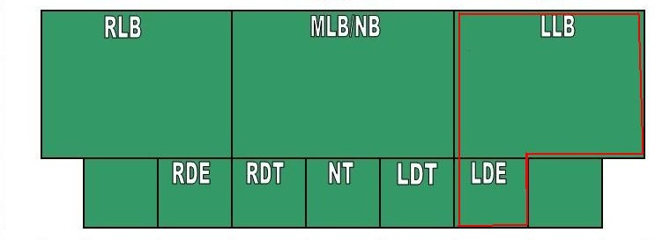
1
2
3
4
5
Token #5 LB has a 50% chance of “stacking” with the LDE Token #1
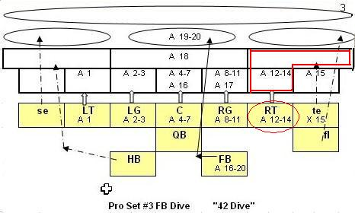

For example, if a running play is called in which the offensive right tackle’s “A” rating is indicated and the zone opposite him is “stacked” with a defensive end having an “A” rating of 2 and a linebacker (in the flat zone) having an “A” rating of 2, the defensive match up total is 5 (2+2+1).

If the offensive tackle’s rating were a 7, he would have only a 30% chance of winning the match up (7 – 5 = 2, so only d10 results of 0 through 2 would win the match up for the offensive team).

If the defensive players win the match up when “stacked”, the player having the lowest number value on their token will have the result read from his card. So, if a defensive end with a token number of 1 and a linebacker with a token value of 5 are stacked and win the match up, the play result will be read from the defensive end’s rating block (card).

The example below shows an automatic stack with the LDE:

1
2
3
4
6
5
7
Linebackers #5 and #6 are “stacked” behind the LDE. This results in an automatic stack with the LDE.

Another strategy involves bringing defensive backs (especially the strong safety) into the rushing “box”. This allows the defense to have more rushing lanes covered or run more blitzes. It also creates more stack chances in at least one lane, depending upon how many defensive-backs you bring up.
A defensive back (in this case, the strong safety, #10), is brought up to play run defense and a stack is automatic for the LDE.

Note: Both DTs would be stacked because of token #6 and #7. An automatic stack would also occur on the FB Dive if the d20 was an 18, with token #6 being the card for defensive results.

1
2
3
4
5
6
10
7

The example below shows no run coverage:
1
2
3
4
6
5
7
Linebackers #5 and #6 and LDE #1 have over committed to their right. This results in wide open lanes on d20 rolls of 12 to 15 (d20 =12-15 on our preceding FB Dive), and correspondingly automatic offensive match up wins. Note: only the secondary might come into play to prevent long breakaways.

Continuing with the example below, let’s assume that the FB Dive play d20 result was a 15 (instead of 12-14 that called on the ROT previously).

In this scenario, the blocker would be the Tight End, utilizing his “x” block rating on a run play. There is no Result Code used if he were to win the match up. The yardage gained on a run would be determined by re-rolling the 2d6 and summing their result for the gain.

As previously depicted, these run plays are looking for defenders in the entire red outlined areas, either in the blitz zones or the linebacker zones, when calling on blocks at the line of scrimmage. In a sense, the run is “looking through” the blitz zones into the linebacker zones also.

This gives great importance to linebackers as they can effectively cover runs and short flat passes from their default positioning in a so called “read and react” mode. When blitzing, they trade that benefit for bigger losses.
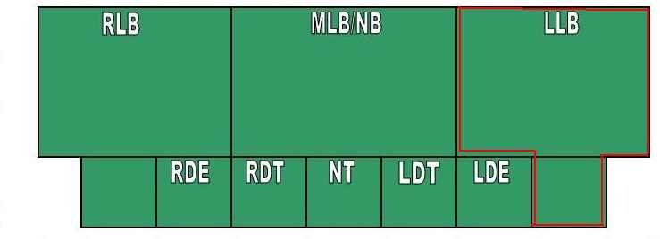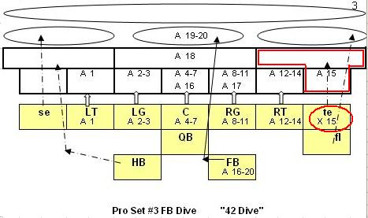
4
3
2
1
5
6
Although the play card indicates a defensive rating check of “A” on d20 roll of 15 in the blitz zone, a defender in the linebacker zone would match up on the play due to “read and react”. However, the Tight End would match up with (lower token) linebacker #5 only. Since the d20 did not call specifically on the linebacker zone where token#5 and token#6 are located, no stack can occur.

The next example will show the type of stack specifically in a linebacker zone.

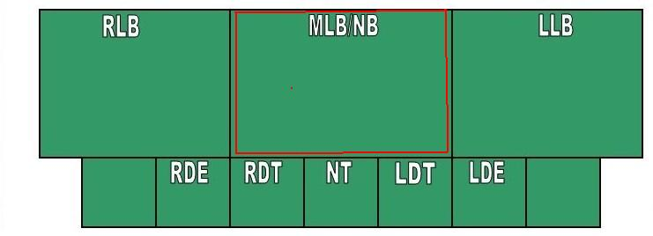
4
3
2
1
6
5

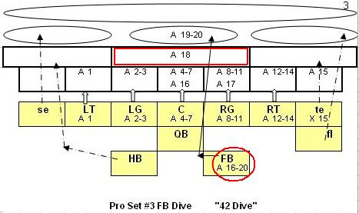

Continuing with the example above, let’s assume that the FB Dive play d20 result was an 18 (instead of 15 that called on the TE previously).

This resulted in the Fullback’s “A” rating matching up with both linebacker’s “A” ratings which results in a stack. Use the token#5 card if they win the match up.

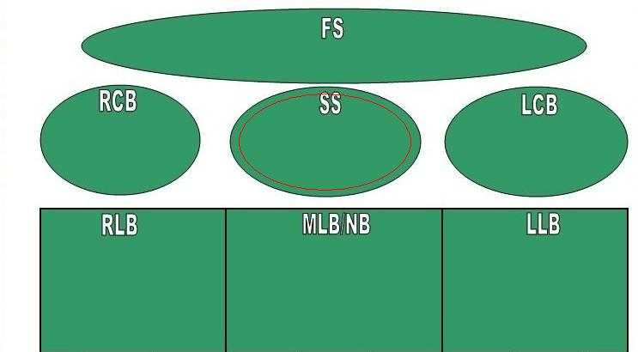
6
5
7
9
11
10

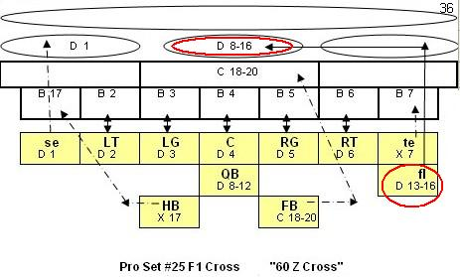

Passing plays require that specifically two defenders occupy the targeted pass zone (short, medium or long). An example is depicted above that assumes a d20 roll of 13.

Note that even a dump-off pass to the Fullback in the middle flat zone on d20 = 18-20 would result in a stack of token#5 and token#7.

However, a dump-off pass to the Split End in the RCB default medium pass oval on d20 = 1 would be an automatic match up win for the Split End.
Blitzing

There are a total of seven blitz zones. In order to “blitz”, defensive players must occupy or have been moved to the very front line prior to the offensive dice roll. A defender in the blitz zone will not move in order to perform other Advanced Game defensive options such as man to man coverage et. al. Essentially, down-linemen are by default always blitzing unless they are moved out of their default positioning.

Linebackers and Secondary players have been given special Result Codes from 92 to 96 whose results are dependent on their blitz status. If they have come on the blitz, they can generate losses on these codes, but will generate gains when not blitzing.
Token#7 has a 50% chance to stack with either Token#2 or Token#3. Also, Token#7 cannot get a loss of yards on RC 92-96 because he is not in the blitz zone.

He is the lone defender on d20 = 4-7, 16, 18

4
3
2
1
5
6
7
Token#6 has a 50% chance to stack with Token#5. Else, Token#5 is the lone defender in the match up. Also, Token#5 could force a loss of yards on RC 92-96 for being in the blitz zone.

Special Teams Play: PUNTS

Use the platoon sheet for quicker ratings and match up determinations.

D20 reveals rush pressure.
D12 reveals penalties, injuries, fumbles or weird plays
D10 reveals yardage adjustments, when needed.
D6 (sum) reveals result codes (RC).

- Offense uses Punting Platoon (Punt Coverage, PC).

- Defense announces any platoon changes (they may choose to keep their defense on the field OR bring in their punt return team).

- Defense moves rushing players into the linemen or linebacker zones.

- Offense announces normal, coffin-corner or fake punt.

- Punt Coverage (PC) team rolls all 5 dice.

- Coffin corner punts require the yardage be reduced by d10 rather than added when punt RC is 31, 32, 41, or 42 only. Furthermore, no returns are allowed.

- Fair Catch punts require a re-roll of d20. Compare to punt returner’s FC rating, if d20 is greater, then a return is permitted.

- Fake punts negate the d12 results and are run like a play from scrimmage.

If the d12 = 1 to 8 use the punter’s appropriate <N or ≥N column if d20 is greater than the # of rushers (defenders placed in the “box”). Otherwise, use the punter’s <R or ≥R column. Add the 2d6 and read the punt result code (RC) off of the punter’s card. Use d10 for any yardage adjustments.

In addition to the d12 = 1 to 8 above:

If the d12 = 9, then a possible penalty has been called during the punt. Re-roll the d10 and use the table below to determine the penalty:

0 | Holding, punting team (15 yds)
1 | False start, punting team (5 yds)
2 | Illegal man downfield, punting team (5 yds)
3 | Offsides, punting team (5 yds)
4 | Offsides, returning team (5 yds)
5 | Roughing, returning team (15 yds)
6 | Personal Foul, returning team (15 yds)
7 | Running into punter, if d6 re-roll = 1 (5 yds),  Else: No Penalty, proceed to return
8 | No penalty, proceed to return
9 | No penalty, proceed to return

Proceed to Punt Return resolution before enforcing/declining penalty.

If the d12 = 10, AND there is rush pressure, a player might have been injured. Check the d10, if 0, then a defensive player might have been injured. If 9, then an offensive player might have been injured. Re-roll the d12 for the token number of the potentially injured player. If d12 = 12, then there is no injury.

If the d12 = 11 AND there is rush pressure, check the 2d6, if 11 also, then the ball is fumbled 10 yards behind line of scrimmage. Otherwise, re-roll the 2d6 and proceed as above for d12 = 1 to 8.

If the d12 = 12, AND there is rush pressure add the 2d6 and consult the Weird Play chart. If a “no change” in the play results, re-roll all 5 dice as per above…but ignore another d12= 12.

Special Teams Play: PUNT RETURNS

D20 reveals players matching up or yardage adjustment.
D12 reveals penalties, injuries, fumbles or weird plays.
D10 reveals match up winner or yardage adjustments if needed.
D6 (added) reveals result codes (RC).

- Punt Return (PR) team decides if it will return punt (FC?) or let it bounce.

- Punt Return (PR) team re-rolls only 4 dice for bounced punts.
If 2d6 match, then the punt bounces towards the line of scrimmage d10 yds
If 2d6 DO NOT match, then the punt bounces forward d20 more yards

- Punt Return (PR) team re-rolls all 5 dice for an elected return.

- Determine match up from platoon sheets or formation/play card from d20.

- Determine match up winner by comparison to d10 as for scrimmage plays.

- Determine RC from the Returns Table by summing d6 as for scrimmage plays.

If the d12 = 1 to 8, and the return team (PR) won the match up, consult the punt returner’s (not match up blocker) PR letter rating (including his long gain) on the Return Table. If the PC team won the match up, use the PC rating for the match up player and use RC of “90” for the long gain.

In addition to the d12 = 1 to 8 above:

If the d12 = 9, then a penalty has been called during the punt return. Re-roll the d10 and consult the table below for the penalty type.

0-3 | Illegal block, returning team (15 yds)
4-6 | Holding, returning team (15 yds)
7 | Face Mask, coverage team (15 yds)
8 | Personal Foul, coverage team (15 yds)
9 | No penalty occurred

To spot foul, re-roll all 5 dice, use RC “90”, but if d6 match, add d20, d12 and d10 to spot the foul (yards after the return).

If the d12 = 10, then the player who lost the match up might have been injured.
If the d12 = 11, then a fumble is possible. Consult fumble procedures.
If the d12 = 12, add the 2d6 and consult the Weird Play chart. If a “no change” in the play results, re-roll all the dice as per above…but ignore another d12= 12.
Special Teams Play: FIELD GOALS & PAT KICKS

D20 reveals rush pressure on kicks
D12 reveals penalties, injuries, fumbles or weird plays.
D10 reveals yardage adjustments, when needed.
D6 (sum) reveals result codes (RC).

- Kicking team uses Field Goal platoon for placekicks within Kicker’s range.

- Yardage is scrimmage line.

- Defensive team makes any platoon changes desired.

- Kicking team selects either the “Field Goal” play card or a “Fake Field Goal” play card, and places it face down.

- Rushing team may move more players into the “box” to rush (block) the kick.

- Kicking team then reveals its play call, kick or fake.

- Kicking team rolls all 5 dice.

- Determine rush pressure. No rush pressure if d20 exceeds number of rushers in the “box”.

- Fake kicks negate the d12 results and are run like a play from scrimmage.

If the d12 = 1 to 8 use the placekicker’s appropriate placekick distance column. Add the 2d6 and read the placekick result code (RC) off of the placekicker’s card under the appropriate column. Use the d10 for any adjustments.

In addition to the d12 = 1 to 8 above:

If the d12 roll is 9, a possible penalty has occurred. After finding the result of the placekick, re-roll the d10 and use the table below to determine whether or not an infraction occurred.

0 | False start, kicking team (5 yds)
1 | Holding, kicking team (15 yds), if re-roll d6 = 1-3.  Else: Encroachment, defensive team (5 yds)
2 | Offsides, defensive team (5 yds)
3 | Unsportsmanlike conduct, defensive team (15 yds and automatic first down for kicking team)
4-9 | No Penalty, proceed to kick

If the d12 = 10 AND there is rush pressure, check the d10, if 0, then a defensive player might have been injured. If 9, then an offensive player might have been injured. Re-roll the d12 for the token number of the potentially injured player. Another d12 = 12 is no injury.

If the d12 =11 AND there is rush pressure, check the 2d6, if 11 also, ball is fumbled 7 yards behind line of scrimmage. Otherwise, re-roll the 2d6 and proceed as above for d12 = 1 to 8

If the d12 = 12, AND there is rush pressure, add the 2d6 and consult the Weird Play chart. If no weird play results, then proceed to kicker’s card for kick result by re-rolling the 2d6 and d10. If there is no rush pressure, then no weird play is possible.

Returning Missed Field Goal Attempts

If a field goal attempted from the 41 yard line or longer was missed AND the defense did NOT send all 11 defenders to rush the kick, then the defense may elect to return the missed field goal from their own end zone. The spot of the ball would be d10 yards deep in the end zone. Apply kickoff return procedures.

Wind

A placekicker’s longest field goal rating may be exceeded or shortened by the wind. The visiting team gets the benefit in the 1st and 3rd quarters and the home team in the 2nd and 4th quarters. Use a d6 roll to determine the yardage change. Do not reduce below the 12 yard line. If a d6 roll increases the distance to a column that has no chance of a good field goal result, then grant a good field goal result on a 2d6 roll of 5.

3. ADVANCED RULES

ADVANCED RULE…Keys on Running Backs and QBs

In order to shut down a specific runner, a “key” may be called. A specific running back or quarterback is keyed after the offense announces that they have selected their play, but before they reveal it.

Keys are initiated by defender Token#6 from a linebacker zone only. If correct (RB/QB AND non-draw running play), the defensive coach may look at the play card the offense selected, and may then move his #6 token (the middle linebacker in a 4-3 defense) anywhere he chooses before the dice are thrown.

If the incorrect back is keyed, but it is still a non-draw running play OR is a play action pass, then token#6 is moved laterally one zone in the direction of the incorrectly keyed back, subject to the limits of zone occupancy.

If a non play action pass OR draw was called, then token #6 is moved forward one zone, subject to the limits of zone occupancy.

ADVANCED RULE…Double Teamed Receivers by FS

A double-team is announced in the same manner as keys, but the free safety (token #11) is moved to the zone in which the double-teamed player finishes the play, even if the intended receiver is not the player the defense is double-teaming.

There is no “wrong” call on a double-team, but keep in mind that moving the free safety out of his usual deep zone may result in a big play. The free safety uses his “D” rating when involved in double teams.

The free safety is placed after any key, but before any man to man or combo coverage movements, subject to zone occupancy limits.

ADVANCED RULE…Spying on the Quarterback

The defense announces that they are spying on the QB in the same manner that they announce keys or double teams.

If a “45” result code comes up during play resolution, the QB does not automatically win the match up. Instead, re-roll the 2d6, and subtract the spying player’s “A” rating from the QB’s “B” rating before comparing to a re-rolled d10. If the QB wins, read the result off his “B” column. If the spy wins, read the result off his “A” column.

The spy is ordinarily the MLB, but you can announce a spy as any one defender in the flat pass zones. If the spy becomes involved in a passing play as a pass defender, subtract 2 from his “C” rating. The spy cannot also key, double team or play man to man/ combo coverage.

ADVANCED RULE…Man-to-Man and Combo Coverage

Man to Man Coverage

In man-to-man coverage defense, each cornerback follows the outermost wide receiver on their side to the zone where they stop, the strong safety is placed into the zone where an inner receiver (for example the tight end) goes, and the free safety follows the other inner receiver, if there is one. If questions arise as to who is covering whom, have the defensive-back with the lowest token number (for example, #8) match up against the offensive receiver with the lowest token number (for example, #2), the next lowest defensive player against the next lowest offensive player, etc.

Running backs are covered by the outside linebackers when playing man-to-man defense. However, when employing the 5-2-4 Short Yardage (goal line) defensive alignment, the left outside linebacker cannot perform both a key and man to man coverage. His default is to key

When called upon, a player in man-to-man coverage will always use his “E” rating, if the play card calls for the D or E rating regardless of what the play card actually calls for. However, if he wins the match up, the play result is read from the column called for on the play card (“C” for short passes, “D” for medium and “E” for long passes).

Defender’s in man to man coverage use their “C” rating when in or moved to the short (flat) zone.

Combo Coverage

Combo coverage is somewhat similar, except that ONLY the cornerbacks are involved (in the same manner as explained for man-to-man coverage). The safeties, linebackers or extra defensive-backs play zone, and so can be moved anywhere before the play card is revealed but not after.

Players playing zone defense will always use their “D” rating, (if the play calls for their D or E rating) regardless of what the play calls for. But if the
defender wins the match up, the play result is read from the column called for on the play card.

Linebackers, strong safeties and extra defensive-backs are not included in combo coverage schemes. Instead, they simply play where they are placed, using the appropriate “C” or “D” rating called upon. Technically, they always play zone defense.

Double-teaming a receiver in these two coverages is allowed. Again, the free safety will move to the location where the double-teamed receiver goes and will move before any combo or man to man movements, subject to zone occupancy limits. A double teaming free safety with coverage responsibilities in man to man coverage will defer to double teaming movement.

ADVANCED RULE…Play Action Pass

When using a “play action pass” play card, cancel all man-to-man, combo and double teaming defensive movements, the defenders are “frozen” and remain in their zone. Use their “C” or “D” ratings.

ADVANCED RULE…Shotgun

Whenever a passing play yields a result code of “47”, “48” or “49” and the offensive formation is “Shotgun”, determine the sack yardage by re-rolling the d12 and 2d6. If the 2d6 match, then use the quarterback’s “A” column for the result code. If not, then use the d12 in place of the normal d10 yardage procedure, still incorporating the 1, 2, and 3 yard modifiers for the various pass types.

ADVANCED RULE…Injuries

Injuries occur to players losing match ups. Roll the d10, add the player’s injury (“inj”) rating to it, and then consult the chart below:

d10 + inj | Injury
14 | Player is injured for one play
13 | Player is injured for one play
12 | Player is injured for one play
11 | Player is injured for one play
10 | Player is injured for one play
9 | Player is injured for the rest of this possession
8 | Player is injured for the rest of this possession
7 | Player is injured for the rest of this quarter
6 | Player is injured for the rest of this quarter
5 | Player is injured for the rest of this half
4 | Player is injured for the rest of this half
3 | Player is injured for the rest of this game
2 | Player is injured for the rest of this game
1 | Player is injured for one more game
0 | Player is injured for one more games
-1 | Player is injured for two more games
-2 | Player is injured for two more games
-3 | Player is injured for three more games
-4 | Player is injured for four more games
-5 | Player is injured for five more games
-6 | Player is injured for the rest of the season
-7 | Player is injured for the rest of the season

ADVANCED RULE…Fatigue

Another optional rule is using fatigue factors. All players have been given a fatigue rating (“Fat”) for use in the PC version. However, only the score sheet system is supported here. Each team’s score sheet indicates an x, xx, or xxx for the skill players. These correspond to a loss of one, two, or three rating points when the number of “touches” reaches the point indicated.

When an intended receiver, passer or ball carrier is fatigued, subtract points from all the offensive players on each play (match up) where the fatigued player ends up touching the ball.

Starting in the fourth quarter only, all defensive players also can become fatigued. These players sit out the number of possessions that correspond to 5 minus their fatigue rating.

4. Solo Play Modifications

Solitaire players may choose to modify the rules slightly to increase game speed. Some of the easiest are:

- You don’t really need the tokens in solitaire play.

- Check the d10 first to see if it abnormally high or low. For example, a roll of 9 is almost always going to be won by the defense, while a d10 roll of 0 is almost always won by the offense.

- Use a zone pass defense. Cornerbacks cover their zones, the strong safety covers the middle medium pass zone, and the free safety covers the long pass zone. Use their “D” rating on all pass plays that call for a D or E rating (but the column referred to on the play card when winning a match up).

- The d12 can be used to select a defensive scheme from the defensive cards,

- For those familiar with BowlBound/Paydirt, use the Pro Set offensive formation play cards and use the following placements for the defenders in the 4-3 alignment.

A (standard) B (short yardage gaps) C (short yardage wide)

11 X X

9 10 8 9 11 8 9 11 8

7 6 5 7 6 10 5 7 6 X 10 5
X4 3 X 2 1X X 4 3 X 2 1 X 4 X 3 X 2 X 1

D (pass prevent short) E (pass prevent long) F (blitz)

use man to man

11 11 10 X

9 10 8 7 9 6 5 8 9 11 8

7 6 5 10
X4 3 X 2 1X 4 X 3 X 2 X 1 7 4 3 6 2 1 5

5. Clarifications

Q: How do defenders move?

A: They are setup in zones while the offense selects its play. They only move (if possible) via keying, double teaming, or man to man/combo coverage after the play is revealed but before the dice are rolled.

Q: How can more than 7 players rush the punter? Also, I understand the benefit (d20 check more likely to result in a rush situation). However, what's the penalty? Doesn't seem that the other two or three guys back there really do much anyway (other than 20 on d20 results is the secondary return guy getting the ball). By rushing two of them, I don't seem to lose much in the punt return.

A: If you move players into the front zone OR the LB zones, they are considered to be rushing the punter. The punter's columns are set up so that they will yield a longer punt when rushed, but have a chance of having the punt blocked. Also, if you move a player from his usual position in order to increase the rush, he is no longer able to block and the kicking team player automatically wins the match up if he rushed.

Q: When a linebacker is brought to the front line to "blitz", I see little benefit in doing this. All he does is leave his linebacker position empty and he would still be filling the hole he is in, even from back there.

A: In order to rush a passer, a player must be in the first set of zones. If an offensive match up (say, involving the center) occurs where there is no player opposite him (blitz zone) on a pass, the offensive player automatically wins the match up. Only a few d20 rolls call on the LB zones specifically. Therefore, a balance of blitzing and "playing it straight" needs to be implemented.

Q: How are sack yards determined?

A: Use the d12 and add 1 if short, 2 if medium and 3 if long (e.g. max loss for long pass is 12+3 is 15 yards). See Advanced Shotgun rule for differences.

Q: Where does the illegal block for RC “12” occur?

A: At the line of scrimmage, spot from there.

Q: Where do the personal foul penalties occur for RC “28” and “29”?

A: These are dead ball fouls, mark penalties from end of the play.

Q: What if the yardage before a personal foul penalty results in a touchdown?

A: If against the defense, touchdown and use on kickoff. If against the offense, spot of the foul is the goal line.

Q: On kickoffs, when the kick reaches the end zone, can the coach choose to return the kick or is it an automatic touchback?

A: The coach can choose to return the kick, but it is recommended that if the kick is more than 3 yards deep, a touchback be taken.

Q: What do I do when a result of “45” comes up?

A: A “45” means that the QB has to scramble. Re-roll the 2d6, add them, and refer to his “B” column for the result of the play.

Q: What do I do when a result of “88” (weird play) comes up?

A: Re-roll both d6, add them, and consult the Weird Play chart.

Q: What happens when fumble yardage puts the ball in the end zone?

A: Touchdown if the offense recovers, touchback if defense recovers or if ball goes out of bounds.

Q: What happens when fumble yardage puts the ball beyond the end zone?

A: Touchback for the defense

Q: The offense is on the opponent’s 41 yard line. Pro Set F1 Fly is called and the result code is “51” and the d10 is 2, so that the yardage is 52 yards. What is the result of the play?

A: It depends on which card, the result code came from. If from the QB or offensive linemen or the defenders, then it is incomplete as they do not reflect any run after catch yardage. If from the receiver, then it is a touchdown (check containment rule) as the excess yardage is read as run after catch.

Q: Some running plays…particularly draws…have match ups listed in the linebacker zones. What do I do?

A: The play is looking for a defender in the zone REGARDLESS of his positioning.

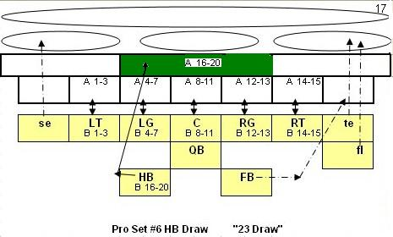

For example: on this play, a roll of 16-20 looks for a defender(s) anywhere in the flat short pass linebacker zone.

Q: Pro Set #8 HB Dive, Defense is playing man to man coverage. Does the RCB move to the A1 blitz zone on the SE?

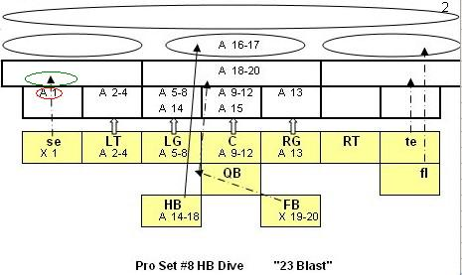

A: No, he moves to the RLB flat pass zone (if occupancy limits allow). However, his “A” rating is compared to the SE’s “x” rating if he were allowed to move (not already fully occupied) and were the only defender in the zone. Also, a stack would occur if the MLB (or another defender) was positioned there with him AND the RLB or another defender were in the blitz zone (the one with the “A1”).

Q: Same play #8 but d20 is 18, the MLB has stayed home and the SS has joined him, is this a stack?

A: Yes, stacks are also two in a zone.

Q: Can a fumbled snap or sack go out of bounds?

A: No, re-roll the d12 to determine a player token other than 12 and use an offensive recovery range of 11-32 for sacks and 11-45 for snaps.

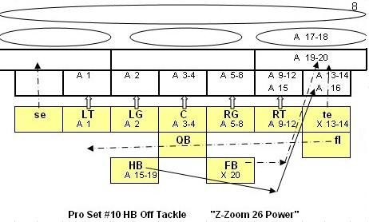
Q: When flankers are in motion like Pro Set #10 HB Off Tackle and the FS has double teamed the flanker, where does he go?

A: He moves laterally one zone in the flanker’s direction, if possible.

Q: When flankers are in motion like Pro Set #10 HB Off Tackle and the LCB is man to man or combo, where does he go?

A: He moves laterally one zone in the flanker’s direction, if possible.

Q: A defense is in “combo coverage” and the CB follows the receiver to the medium middle pass zone (like the ProSet #25 Flanker Cross previously depicted), which is occupied by the SS, how is the match up resolved?

A: This is a stack. Use both the CB’s “E” and SS’s “D” rating and grant a stack bonus of 1 before subtracting the offense.

Q: A defense is in “combo coverage” and the CB follows the receiver to the medium middle pass zone (like the ProSet #25 Flanker Cross previously depicted), which is occupied by the SS, but the FS is double teaming the flanker, how is the match up resolved?

A: The FS moves before the combo coverage. This is a stack of the FS and SS. Use both the FS’s “D” and SS’s “D” rating and grant a stack bonus of 1 before subtracting the offense. The CB cannot move.

